Dynamic Pricing for Urban Parking Lots

Summer Analytics 2025 – Submission Report by Shraddha Nigam

# Project Overview

In modern urban environments, parking is a scarce and often mismanaged resource. Static pricing schemes, where parking prices remain fixed regardless of real-time conditions, lead to inefficiencies such as overcrowded lots in high-demand areas and underutilized spaces elsewhere. To tackle this, dynamic pricing offers a data-driven approach that adapts to real-time conditions—including demand, vehicle types, traffic congestion, and special events—to optimize parking lot usage.  
  
This project, as part of Summer Analytics 2025, involves building a real-time pricing engine for 14 urban parking spaces using real-world-inspired data. The aim is to implement two models:  
1. A baseline model that adjusts prices linearly with occupancy.  
2. An advanced demand-based model that factors in queue lengths, traffic, vehicle type, and special events.  
  
The system is built using Python, NumPy, Pandas, and Bokeh for visualization, with simulated real-time data streaming handled via Pathway-style logic. All models are developed from scratch, ensuring transparency and interpretability. The final outcome is a dynamic and explainable pricing system that could improve the operational efficiency and user experience of urban parking infrastructure.

# Model 1: Baseline Linear Pricing

Objective: Adjust price linearly with occupancy

Formula: Price_t = 10 + α × (Occupancy / Capacity)

Parameter: α = 2.0

Features Used: Only utilization (Occupancy ÷ Capacity)

This model produces smooth and predictable price variations as occupancy increases.

# Model 2: Demand-Based Pricing

Objective: Build a more intelligent pricing function using multiple real-time features

Demand Function: D = α × (Occupancy / Capacity) + β × Queue - γ × Traffic + δ × SpecialDay + ε × VehicleWeight  
Normalized Demand: Scaled between 0 and 1 per lot  
Final Price: Price = 10 × (1 + λ × NormalizedDemand)

Parameters: α=1.5, β=0.8, γ=0.5, δ=1.0, ε=1.2, λ=0.6

Price bounds: clipped between $5 and $20

This model incorporates multiple dimensions of real-time parking behavior.

# Visualization

Tool Used: Bokeh  
Output: Real-time line plot comparing Model 1 vs Model 2 prices for each LotID

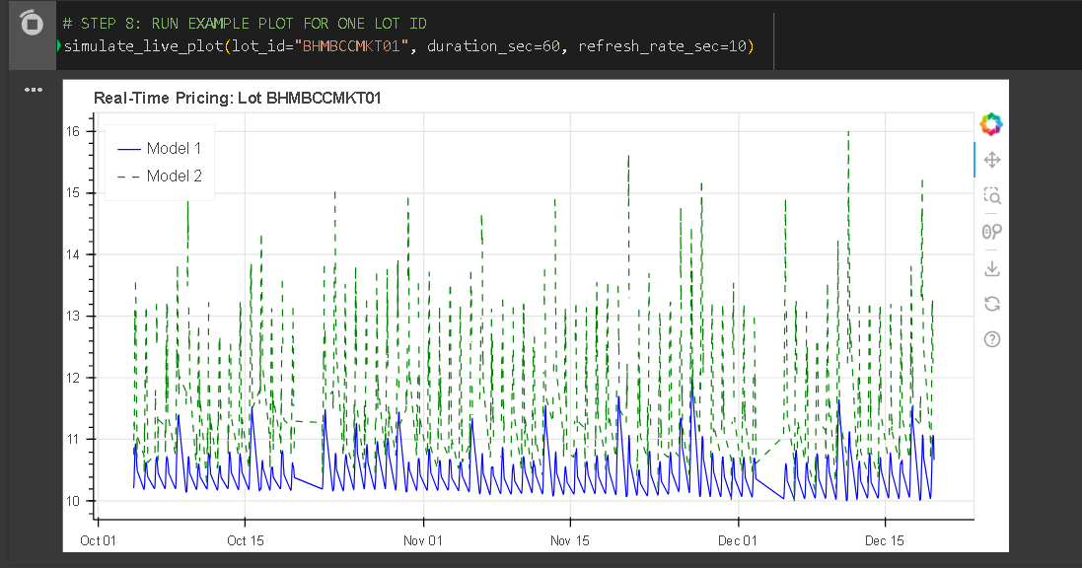

Screenshot taken while code was running as the plot flickers due to platform issues.

# Files Submitted

- parking_dynamic_prices.csv – final output  
- live_pricing_output.json – simulated stream  
- Colab notebook – <https://colab.research.google.com/drive/1OyDzdIbSVYNGYxfLlZBpMcndFoDrG-6b?usp=sharing>  
- Report